**Minimalist-hand-paint-abstract-art**

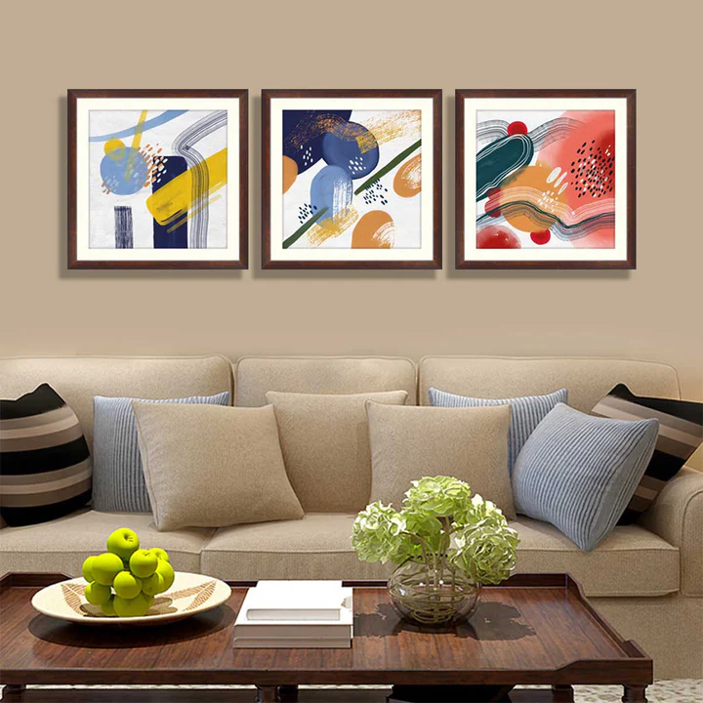This minimalist hand-painted abstract art set features a harmonious blend of earthy tones, including warm orange, deep blue, and golden yellow, layered in flowing watercolor-like patterns. The designs are accentuated by the subtle addition of crane birds in flight, evoking a sense of calm and balance. Framed in clean black borders, the artwork embodies simplicity and elegance, making it a versatile choice for modern interiors. Complemented by a cozy seating area adorned with striped and solid cushions, this setup seamlessly merges contemporary design with artistic charm, creating a serene and stylish ambiance.